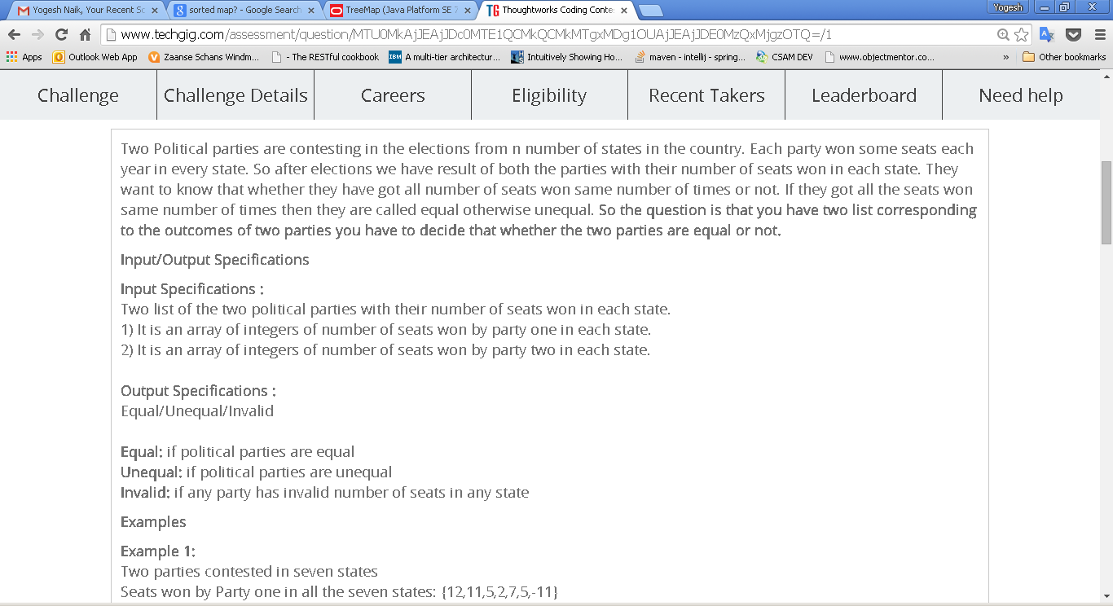

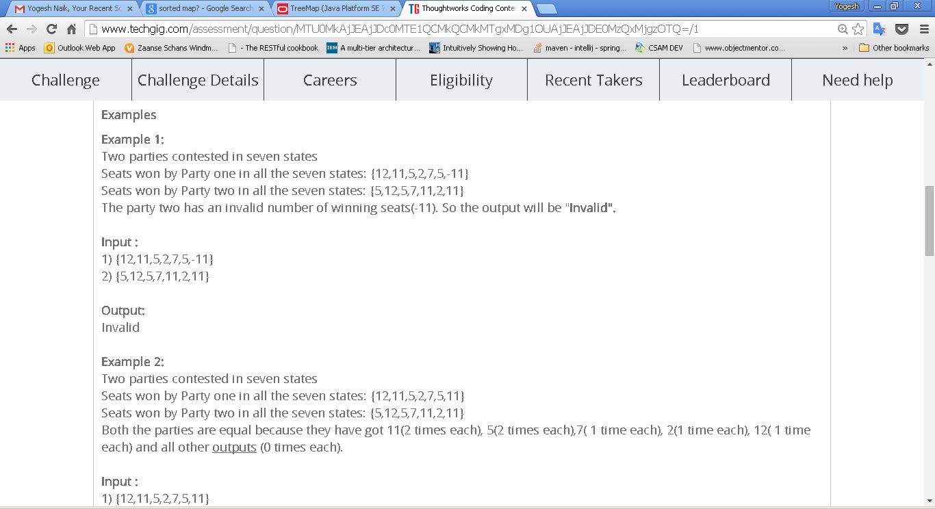

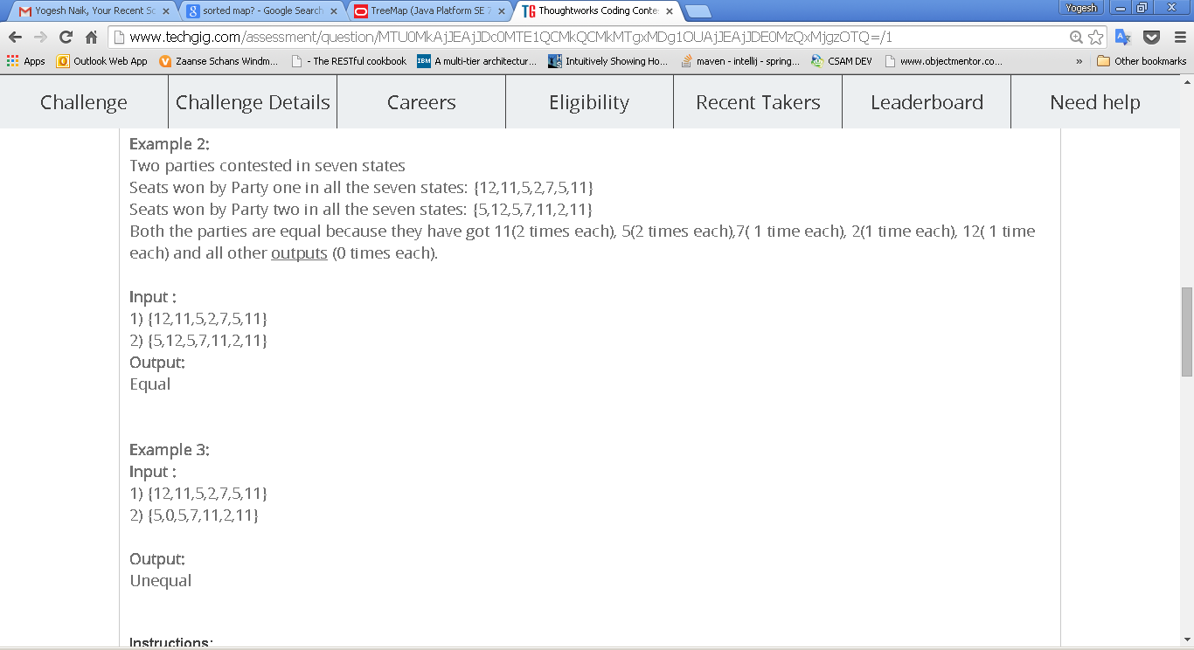

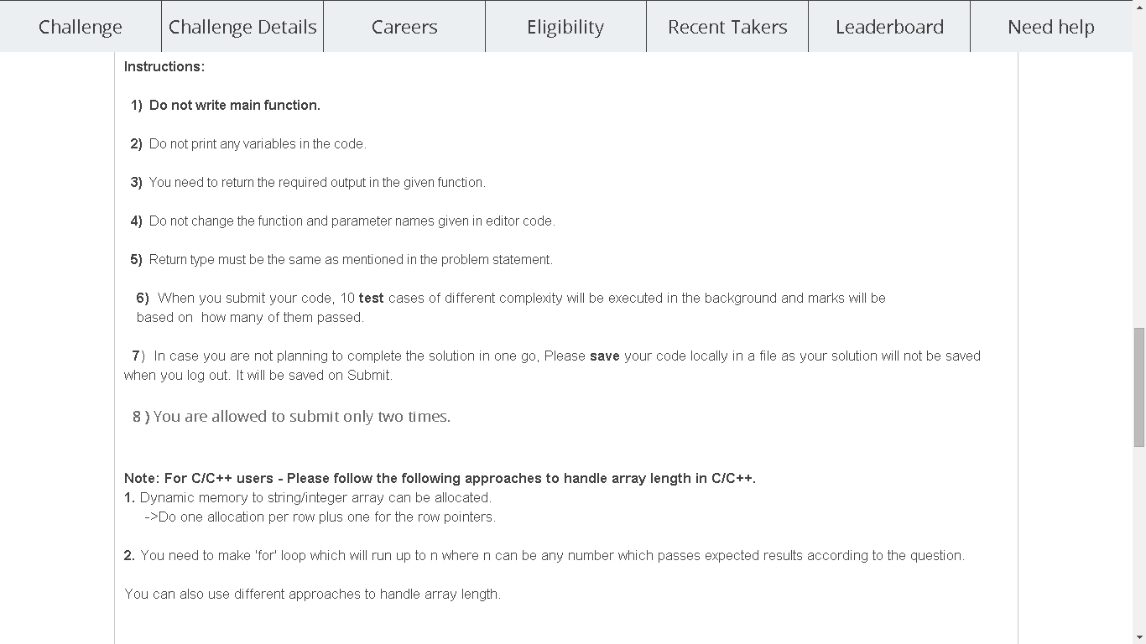

|  |
| --- |
| import java.io.*;  public class CandidateCode  {  public static String partiescompare(int[] input1,int[] input2)  {  //Write code here  }  } |